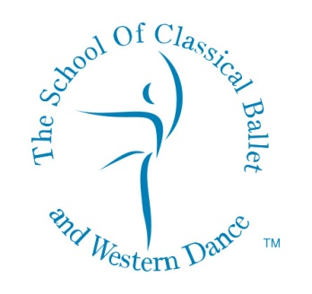
The School of Classical Ballet and Western Dance
412, Panchshil Plaza, A Wing, 4th floor, Near Dharam Palace, Gamdevi Road, Mumbai 400007.
Tel: 23620026/ 27 Mobile: 9920253172 info@balletindia.com www.balletindia.com

AUDITION WORKSHOP FORM

(PLEASE FILL IN BLOCK LETTERS)

PUPIL’S NAME _________________________________________________________________________

ACADEMIC SCHOOL ATTENDED: _________________________________________________________

ACADEMIC SCHOOL TIMINGS:______________ to_______________

DATE OF BIRTH: _____________________________________________

AGE (AS OF SEPTEMBER 2023) ________________Yrs.________________Mths

DANCE CLASSES ATTENDED (IF ANY)_____________________________________________________

DURATION OF DANCE CLASSES ATTENDED ________________Yrs.________________Mths
(In case your child has appeared for any dance examinations, please email scanned copy of the report
to info@balletindia.com)

LOCATION PREFERENCE (please tick whichever applicable) – BANDRA / SOUTH MUMBAI

DATE: _________________________________________________________________

SIGNATURE OF PARENT: ________________________________________________

Mobile Number: __________________________________________________________

Telephone Numbers :(R)___________________________ (O)______________________

Email Address: ___________________________________________________________

Referred by: ___________________________________________________________

Khushcheher Dallas, LRAD, ARAD, LISTD (London)
Director

Tushna F. Dallas, FISTD ARAD (London)
Founder

